5 Break
Workshop #5
Flutter Developer Bootcamp

Purpose
This workshop demonstrates how to use a break statement in the code, Which is used to immediately stop the for loop when the variable i reaches 5, preventing further iterations.

Problem
In the given workshop The provided Dart code snippet features a for loop that iterates from 0 to 15. During each iteration, it prints the current value of i to the console. However, when the loop reaches i = 5, a conditional check (if (i == 5)) triggers a break statement. This causes the loop to terminate immediately after printing 'breaked in 5'. As a result, any subsequent iterations from 6 to 15 are skipped entirely. This example effectively demonstrates the break statement's role in controlling program flow within loops, enabling early termination based on specific conditions.You need to print ‘breaked in 4’ , make break statement in number 4.

How to Solve
- Checkout the workshop from Git Repo:
git clone -b <user-branch> <repo-URL>
- Open the root folder inside VS Code
- Open the root folder in terminal
- Run the command dart run filename.dart
- The Dart code snippet starts with a for loop iterating from 0 to 15.
- During each iteration, it prints the current value of i to the console (print(i);).
- When i equals 4 (if (i == 4)), the code prints 'breaked in 4'.
- Immediately after printing, the break; statement is encountered.
- This break; statement causes the loop to terminate prematurely.
- As a result, any subsequent iterations from 5 to 15 are skipped entirely.
- Go To File: <specific-file--method> à <method-name>, implement your logic.

You will Achieve
When you complete this workshop you will learn the following:

Methods and Functions Used:

- Main Function (main):
- Entry point of Dart programs where execution begins.
- Uses the main function signature: void main(List<String> args).
- For Loop:
- Iterates over a sequence of numbers using for (int i = 0; i <= 15; i++).
- Starts with i initialized to 0, increments i by 1 after each iteration, and continues until i is 15 (i <= 15).
- Conditional Statement (if):
- Checks a condition within the loop using if (i == 4).
- Executes a block of code if i equals 4.
- Print Function (print):
- Outputs the current value of i during each iteration of the loop (print(i);).
- Displays the message 'breaked in 4' when the condition i == 4 is met (print('breaked in $i');).
- Break Statement:
- Used to terminate the loop immediately upon meeting the condition i == 4.
- Stops further execution of the loop and exits it prematurely (break;).

Screenshots

Before implementation (without making break in 4)

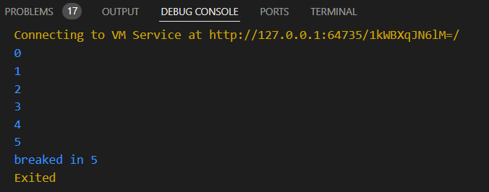

After implementation (with making break in 5)

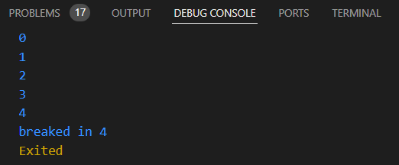

How to submit your workshop
Push your project back to the same git branch using command:
<command name>

Happy Coding!

